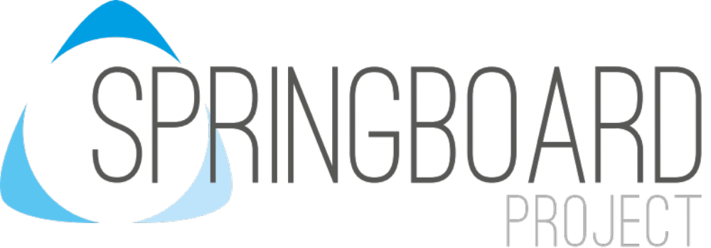
RSE Policy

Document Control Information
Document Title |  |  | SRE Policy
Organisation / Site |  |  | Springboard Project
Review Period : |  |  | Every 3 years
Document Owner and Reviewer: |  |  | Head of Site
Approval Committee |  |  | Governors
Revision and Approval History
Author |  | Summary of changes |  | Issue | Date Applicable From | Approved by | Date of Next  Review
S Lund |  | New policy |  | 1 | 31/08/2019 | Governors | 31/08/2022
A Ward |  | Review 1 change |  | 2 | Sept 2024 | Governors | Sept 2027
Equality Impact
Statement  Screening | We welcome feedback on this document and the way it  operates. We are interested to know of any possible or actual adverse impact that may affect any groups in respect of any of the equalities act 2010 protected characteristics.  The person responsible for equality impact assessment for this document is the Director of Equality and Diversity.  This document has been screened by the Equality Team and the impact has been assessed as:  - Not applicable  - Low  - Medium  - High

- Purpose
  - The purpose of this policy is to describe our practice in providing relationship and sex education (RSE).
  - RSE is about the emotional, social and cultural development of pupils and involves learning about relationships, sexual health, sexuality, healthy lifestyles, diversity and personal identity.
  - RSE involves a combination of sharing information, and exploring issues and values.
  - RSE is not about the promotion of sexual activity.

- Scope of Policy
  - This policy applies to all stakeholders. It sets our approach to RSE.

- Reason for Review
  - This document was written as part of a Group policy audit.

- Aim(s)
  - To help pupils:
    - form and maintain appropriate relationships of all kinds with peers, family members, carers and friends
    - understand and learn social boundaries i.e. what is and what is unacceptable
    - understand the feelings they may have and how to express them appropriately
    - know about the ways their bodies work and the changes as they grow
    - increase self-awareness and facilitate a development of self-advocacy
    - develop interpersonal, decision making and assertiveness skills
    - develop the skills to recognise and reduce the risk of abuse and exploitation

  - To enable pupils to know their rights and responsibilities to:
    - understand themselves better and to encourage independence through clear practical information and guidance
    - protect themselves against sexual abuse and exploitation
    - understand their rights to sexual expression within the law
    - identify sources of appropriate information and facilities for personal support
    - develop and maintain appropriate relationships with greater independence
    - develop an understanding of appropriate sexual behaviour
    - access support from specialist staff to help with the specific issues around sexual behaviour
    - develop awareness of the link between rights and responsibilities
    - develop the ability to make informed choices and decisions
    - develop mutual and self-respect
    - develop an individual knowledge and understanding of the risks involved in particular behaviours, including internet use in this context.

- Procedures and practice
  - The Assistant CEO Standards is the designated teacher with responsibility for co-ordinating RSE.

  - The RSE curriculum is based around a modular programme, incorporating national guidelines. It is supported by the underlying philosophy embedded in the values and attitudes upheld in New Bridge Multi Academy Trust (MAT).

  - Parents have the right to withdraw their child from sex education element of the RSE curriculum. Dialogue with parents on this matter will be recorded. However, the school would strongly recommend that all pupils have access to these modules and staff are happy to discuss any details with parents. There is no right to withdraw from Relationships Education or Health Education (Para 50 Draft Guidance 2019)

  - Parents do not have the right to withdraw their child/children from statutory elements of sex education that we teach as part of the statutory National Curriculum for Science. These are:

    - Key Stage 3 & 4
      - Discrete RSE is delivered using the school scheme of work. These modules remain a working document commensurate with the specific needs of the individual pupils. Some aspects will be taught in single gender groups as appropriate.

    - Key Stage 5
      - RSE is addressed in 16-19 provision in targeted sessions that make up part of the timetable. This is in the PSHE LTP

  - Every child is entitled to receive RSE regardless of ethnicity, gender, religion, age, culture, disability, sexuality, language, specials needs or disadvantage. It is our intention all children have the opportunity to experience a programme of RSE at a level which is appropriate for their age and physical development with differentiated provision if required.

  - RSE is delivered through all areas of the curriculum, taught by classroom teachers, teaching assistants and if appropriate, outside visitors such as the school nurse. It is also delivered as a discrete subject as part of the Living Skills curriculum.

  - A range of teaching methods which involve children’s full participation are used to teach RSE. These include use of media clips, discussion, social stories, drama and role-play. RSE is usually delivered in mixed gender groups.

  - For assessment, recording and reporting purposes teachers will look for understanding in relation to maturity and build on previous experiences. Assessments will be made in discussion with the pupils themselves.

  - There are central resource such as books, videos, artefacts, social stories and materials to photocopy. Those of a sensitive nature are stored separately. Additional resources may be loaned from external agencies.

  - All materials used are suitable to the age and cultural background of the individuals and appropriate to the level of need.

  - Equal opportunities
    - We aim to provide an environment that is free from discrimination on any grounds including gender, race, ethnicity, colour, nationality, disability, sexual orientation, age and religious or political belief.

    - We believe that pupils will benefit from an approach which recognises that learners may be at different stages of emotional, social, physical, personal and intellectual growth and therefore may require their opportunities to learn to be adapted within the same curriculum.

    - When teaching RSE we acknowledge that individual families will have their own cultural diversity and ethos in relation to human sexuality and sexual relationships. We cannot deliver individualised moral guidance to pupils but will ensure that the RSE delivered is never value free and we will support parents in how best they may approach moral issues with their child if they wish.

    - We support the right of all pupils and staff to equal access and chances, regardless of ethnicity, gender, social circumstances, ability / disability, belief, age or sexuality.

  - Health and safety
    - Health and Safety issues are described fully in the school Health and Safety Policy. It is the responsibility of each adult to report health and safety issues without delay.

  - Professional Development
    - All staff are provided with training opportunities to deliver the curriculum where appropriate. Training needs will be identified and discussed with the Training and Development Director. All staff responsible for organising and implementing discrete RSE throughout the school are provided with the opportunity to attend relevant courses.

  - Confidentiality
    - Parents are kept informed of the content of the RSE curriculum. Children’s individual needs will not be discussed in a classroom setting, fictitious examples are used. During RSE sessions a ‘private’ sign will be placed on the classroom door indicating the importance of confidentiality to pupils. Teachers maintain confidentiality. Child protection concerns would override all other consideration including confidentiality.

  - Child Protection Procedures
    - Our Child Protection policies and procedures are in a separate document and staff will follow these procedures if a child discloses information or displays behaviour that may cause the member of staff concern.

- Sources and references
  - Sex and Relationship Guidance DfEE 0116/2000
  - Relationships Education, Relationships and sex Education (RSE) and Health
  - Education Draft Statutory Guidance. Feb 2019

- Other useful documents
  - Child Protection Policy

- Monitoring
  - This policy will be monitored through the MAT’s accountability framework.

